**AGES AND PERCENTAGE :**

1.Use algebraic equations to represent age relationships.

2. Percentage increase: New value = Original value + (Original value * Percentage increase)

3. Percentage decrease: New value = Original value - (Original value * Percentage decrease)

------------------------------------------------------------

**EXAMPLE PROBLEM:**

**Ages:**

1. Problem: A father is 30 years old, and his son is 5 years old. In how many years will the father be three times as old as his son?

Solution:

- Step 1: Let x be the number of years.

- Step 2: Father's age after x years = 30 + x

- Step 3: Son's age after x years = 5 + x

- Step 4: According to the problem, 30 + x = 3(5 + x)

- Step 5: Solve for x: 30 + x = 15 + 3x

- Step 6: 30 - 15 = 3x - x

- Step 7: 15 = 2x

- Step 8: x = 7.5 years

2. Problem: A person's age after 15 years will be three times his age 5 years ago. What is his present age?

Solution:

- Step 1: Let present age = x

- Step 2: Age 5 years ago = x - 5

- Step 3: Age after 15 years = x + 15

- Step 4: According to the problem, x + 15 = 3(x - 5)

- Step 5: Solve for x: x + 15 = 3x - 15

- Step 6: 15 + 15 = 3x - x

- Step 7: 30 = 2x

- Step 8: x = 15 years

---------------------------------------------------------------

**EXAMPLE PROBLEM OF PERCENTAGE:**

1. Problem: A shirt is priced at $80. If it's on sale for 20% off, how much will you pay?

Solution:

- Step 1: Original price = $80

- Step 2: Discount = 20% of $80 = 0.2 × $80 = $16

- Step 3: Sale price = Original price - Discount = $80 - $16 = $64

2. Problem: A student scored 75% on a test. If the test had 80 questions, how many questions did the student answer correctly?

Solution:

- Step 1: Total questions = 80

- Step 2: Percentage scored = 75%

- Step 3: Correct answers = 75% of 80 = 0.75 × 80 = 60 questions

====================================================================

**COMPOUND INTEREST & SIMPLE INTEREST:**

**Compound Interest:**

1. Formula: A = P(1 + r/n)^(nt)

- A = final amount

- P = principal amount

- r = annual interest rate

- n = number of times interest is compounded per year

- t = time in years

**EXAMPLE PROBLEM OF COMPOUND INTEREST:**

1. Problem: Find the amount and CI on ₹1000 at 5% per annum compounded annually for 2 years.

Solution:

- Step 1: P = ₹1000, R = 5%, n = 2 years

- Step 2: A = P(1 + R/100)^n = 1000(1 + 5/100)^2 = 1000(1.05)^2 = ₹1102.50

- Step 3: CI = A - P = ₹1102.50 - ₹1000 = ₹102.50

2. Problem: A sum of ₹5000 amounts to ₹6655 in 3 years at CI compounded annually. Find the rate of interest.

Solution:

- Step 1: P = ₹5000, A = ₹6655, n = 3 years

- Step 2: A = P(1 + R/100)^n

- Step 3: 6655 = 5000(1 + R/100)^3

- Step 4: Solve for R: (1 + R/100)^3 = 6655 / 5000 = 1.331

- Step 5: (1 + R/100) = ∛1.331 ≈ 1.1

- Step 6: R = (1.1 - 1) × 100 = 10%

------------------------------------------------------------------

**Simple Interest:**

2. Formula: SI = (P * R * T) / 100

- SI = simple interest

- P = principal amount

- R = annual interest rate

- T = time in years

**EXAMPLE PROBLEM OF SIMPLE INTEREST**

1. Problem: Find the SI on ₹1000 at 5% per annum for 2 years.

Solution:

- Step 1: P = ₹1000, R = 5%, T = 2 years

- Step 2: SI = (P × R × T) / 100 = (1000 × 5 × 2) / 100 = ₹100

2. Problem: A sum of ₹5000 amounts to ₹6000 in 4 years at SI. Find the rate of interest.

Solution:

- Step 1: P = ₹5000, A = ₹6000, T = 4 years

- Step 2: SI = A - P = ₹6000 - ₹5000 = ₹1000

- Step 3: R = (SI × 100) / (P × T) = (1000 × 100) / (5000 × 4) = 5%

======================================================================================================================

--------------

**VISUAL REASONING , PUZZLES AND ANALOGIES:**

**1.Visual Reasoning - Charts**

- No specific formula, but involves:

- Interpreting data from charts and graphs.

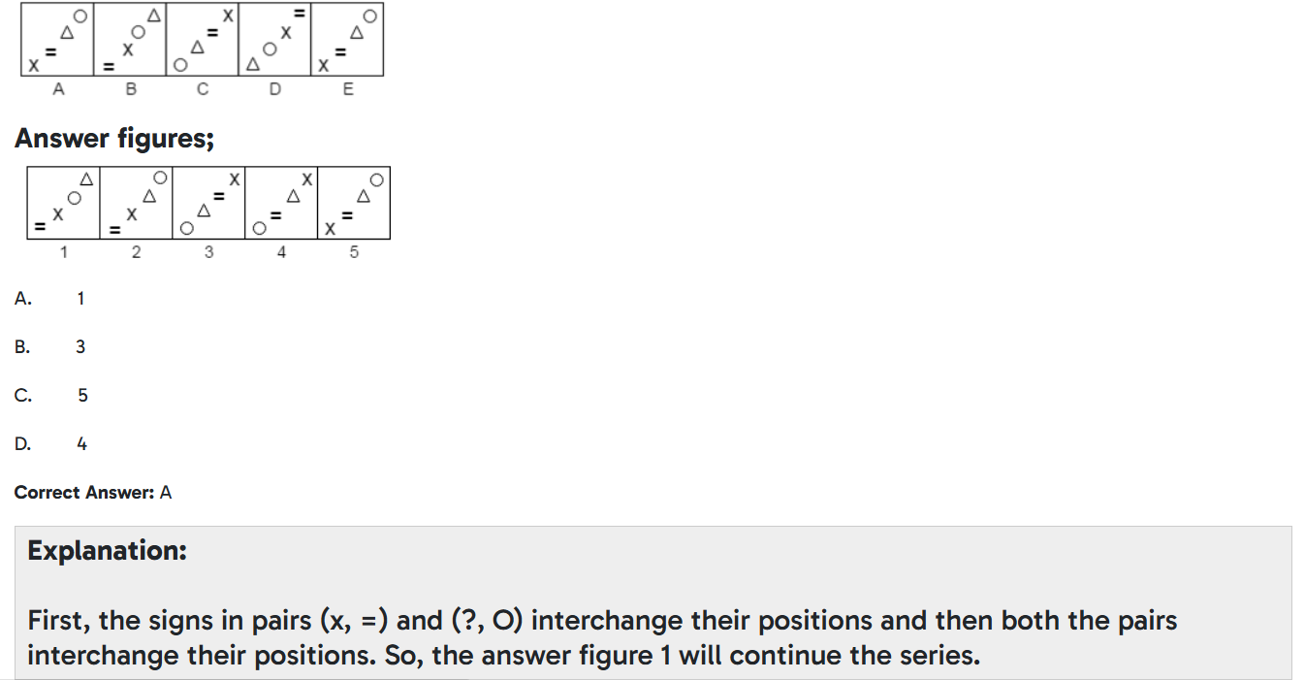

2. 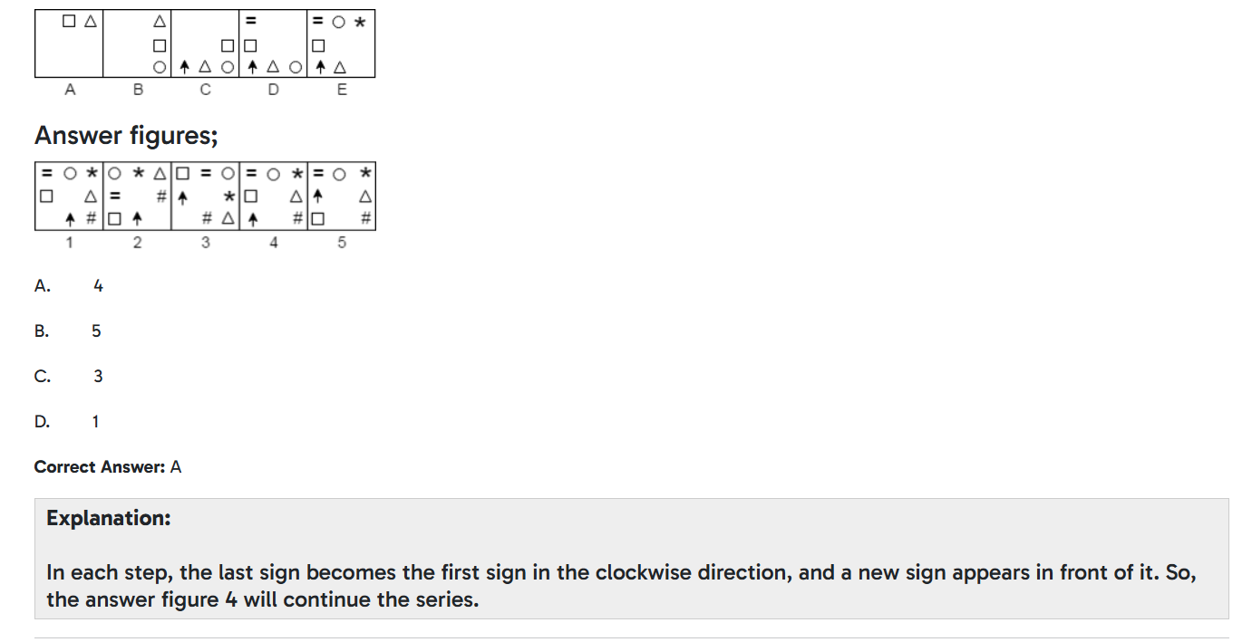

**2. Puzzles**

- No specific formula, but involves:

- Logical reasoning and problem-solving.

- Identifying patterns and relationships.

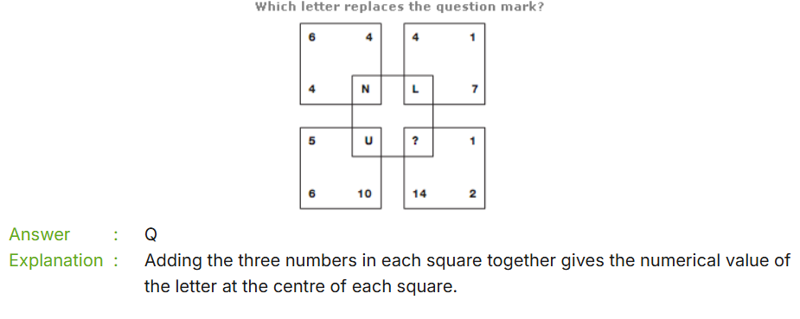

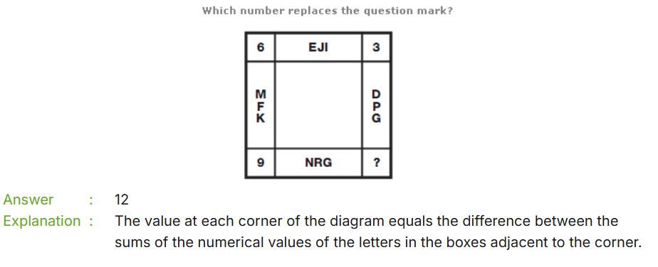

**3.7. Analogies**

- No specific formula, but involves:

- Identifying relationships between words or concepts.

- Recognizing patterns and similarities.

